VERITAS CYBERSECURITY PLATFORM
PHASE 1 — SYSTEM IDENTITY, PROBLEM DEFINITION & HARD CONSTRAINTS
(PRD Sections 1–3)

SECTION 1: SYSTEM IDENTITY
1.1 Application Name (Final & Fixed)
Veritas Cyber Threat Reporting & Intelligence Platform
Short Name: V-CTRIP
This name is immutable across codebase, documentation, and deployment artifacts.

1.2 System Classification
- System Type: Web-based Cybersecurity Reporting & Intelligence Platform
- Domain: Cybersecurity / Institutional Security / Academic Research
- Operational Context: University environment (Veritas University case study)

1.3 Primary User Groups (Explicit)
- Students & Staff (Reporters)
Individuals who experience or observe cyber threats.
- Security Analysts (ICT / SOC-equivalent)
Institutional staff responsible for reviewing, validating, and analyzing reports.
- System Administrators
Personnel responsible for governance, configuration, and audit oversight.
No anonymous users are permitted anywhere in the system.

SECTION 2: CORE USER PROBLEM (PRECISE DEFINITION)
2.1 The Problem
University environments experience:
- Phishing attacks
- Credential compromise
- Malware distribution
- Social engineering
- Account impersonation
- Data misuse
However:
- Reports are informal or fragmented
- Data is unstructured
- There is no intelligence lifecycle
- Security teams lack historical visibility
- Existing tools (e.g., Google Forms) provide:
  - No rate limiting
  - No validation guarantees
  - No access control
  - No intelligence generation
  - No auditability
  - No scalability guarantees

2.2 Why Existing Solutions Fail
Limitation | Consequence
Generic forms | Garbage data
No security controls | Abuse & spam
No validation | Inconsistent reports
No analytics | No learning
No role separation | Security risk
No scaling model | System failure

2.3 The Core Problem Statement (Academic-Grade)
There is no secure, scalable, and intelligence-driven platform within the university environment capable of transforming cyber threat reports into validated, analyzable, and actionable institutional cyber intelligence.

SECTION 3: SYSTEM OBJECTIVES & HARD CONSTRAINTS
This section defines non-negotiable rules the AI agent must obey.

3.1 Primary System Objectives
The system must:
- Provide a secure reporting channel for cyber incidents
- Enforce structured, validated input at all times
- Convert reports into institutional cyber threat intelligence
- Support 4,000–7,500 users without degradation
- Apply OWASP threat modeling principles by design
- Enforce rate limiting on every single endpoint
- Maintain auditability and traceability of all actions

3.2 Non-Negotiable Security Constraints (Hard Rules)
These are system invariants.
- ❗ Every API endpoint MUST have rate limiting
- ❗ Every user input MUST be validated server-side
- ❗ No endpoint may trust client-side validation
- ❗ No plaintext passwords anywhere
- ❗ No shared roles without explicit permissions
- ❗ No direct database access from the frontend
- ❗ No functionality outside authenticated sessions
- ❗ No assumption of localhost-only operation
If any of these are violated, the system is considered incorrectly implemented.

3.3 Scalability Constraints (Explicit Numbers)
The system must be designed to support:
- Minimum concurrent users: 4,000
- Maximum concurrent users: 7,500
- Traffic profile: Burst-heavy (incident spikes)
- Concurrency model: Stateless backend
The system must behave identically on localhost, staging, and production.

3.4 System Non-Goals (Explicitly Out of Scope)
The system will NOT:
- Perform active intrusion detection
- Perform packet sniffing
- Hack back attackers
- Replace enterprise SIEM tools
- Monitor network traffic directly
- Operate anonymously

PHASE 2 — SECURITY & OWASP-DRIVEN ARCHITECTURE
SECTION 4: SECURITY ARCHITECTURE PHILOSOPHY
4.1 Security-First Design Principle
V-CTRIP shall be designed under a “secure-by-default” model:
- No feature is usable unless explicitly allowed
- No endpoint is public unless explicitly declared
- No data is accepted unless explicitly validated
- No trust is placed on client behavior
- No assumption is made about benign usage

4.2 OWASP Threat Modeling Mandate
The system must explicitly defend against the OWASP Top 10 categories, mapped directly to system components.
OWASP Risk | Mandatory Mitigation
Injection | Strict validation, ORM-only queries
Broken Auth | JWT, secure hashing, session expiry
Sensitive Data Exposure | HTTPS, encryption, no plaintext
Broken Access Control | Role + permission checks
Security Misconfiguration | Hardened defaults
XSS | Input sanitization + output encoding
CSRF | CSRF tokens on state-changing requests
Insecure Deserialization | Typed DTOs only
Logging Failures | Immutable audit logs
SSRF | No external fetch without whitelist

SECTION 5: RATE LIMITING (ABSOLUTE REQUIREMENT)
5.1 Global Rule
Every single API endpoint MUST be rate-limited.
There are NO exceptions.
Rate limiting must be enforced server-side and applied before business logic executes.

5.2 Rate Limiting Strategy (Explicit)
Rate limits are defined by endpoint class, not individual routes.
5.2.1 Authentication Endpoints
Examples:
- /auth/login
- /auth/register
- /auth/refresh
Limits:
- 5 requests per minute per IP
- 3 failed attempts → temporary lock (15 minutes)

5.2.2 Reporting Endpoints
Examples:
- /reports/create
- /reports/update
- /reports/submit
Limits:
- 20 requests per minute per authenticated user
- Burst protection enabled

5.2.3 Read-Only Endpoints
Examples:
- /dashboard
- /reports/list
- /analytics/view
Limits:
- 60 requests per minute per user

5.2.4 Administrative Endpoints
Examples:
- /admin/users
- /admin/config
- /admin/audit-logs
Limits:
- 30 requests per minute
- Admin-only role enforcement required

5.3 Abuse Handling
If a rate limit is exceeded:
- HTTP 429 Too Many Requests is returned
- Event is logged in AuditLogs
- Repeated abuse escalates to temporary suspension

SECTION 6: INPUT VALIDATION & DATA INTEGRITY
6.1 Absolute Validation Rule
No data shall enter the system without validation.
No exceptions. No trust.
Validation occurs:
- Client-side (UX only)
- Server-side (authoritative)

6.2 Validation Coverage (Mandatory)
Validation must be applied to:
- All request bodies
- All query parameters
- All route parameters
- All file uploads
- All headers used for logic
- All decoded JWT payloads

6.3 Validation Standards
Every input must define:
- Type
- Length
- Format
- Allowed values
- Required/optional state
- Sanitization rules
Example (Threat Report Description):
- Type: string
- Min length: 20 characters
- Max length: 2000 characters
- HTML disallowed
- Script tags stripped
- Unicode normalized

6.4 File Upload Security
Evidence uploads must:
- Be optional
- Accept only whitelisted MIME types
- Enforce max file size
- Be virus-scanned (where possible)
- Be stored outside web root
- Be referenced by ID, not path

SECTION 7: AUTHENTICATION & AUTHORIZATION MODEL
7.1 Authentication (Hard Rules)
- JWT-based authentication
- Short-lived access tokens
- Secure refresh token rotation
- Passwords hashed using bcrypt
- No plaintext password storage
- No credentials in logs

7.2 Authorization (Role + Permission)
Access decisions must require:
- Valid JWT
- Valid role
- Explicit permission
Role | Capabilities
Reporter | Create & view own reports
Analyst | Review, classify, analyze
Admin | System governance & audit

7.3 Access Control Enforcement
- Authorization checks must occur at controller level
- No UI-based access control is trusted
- All role violations are logged

SECTION 8: AUDIT LOGGING (SECURITY CRITICAL)
8.1 What Must Be Logged
- Authentication attempts
- Report submissions
- Status changes
- Administrative actions
- Rate limit violations
- Permission violations

8.2 Audit Log Properties
Audit logs must be:
- Immutable
- Timestamped
- User-attributed
- Non-deletable
- Queryable by admins only

SECTION 9: FAILURE & MISUSE HANDLING
9.1 Failure Rules
- No stack traces exposed to users
- Generic error messages externally
- Detailed errors logged internally

9.2 Misuse Cases (Explicit)
The system must expect:
- Spam reporting
- Credential stuffing
- Automated abuse
- Privilege escalation attempts
Each misuse must trigger:
- Rate limiting
- Logging
- Escalation if repeated

PHASE 3 — EXACT TECHNOLOGY STACK & IMPLEMENTATION MANDATES
SECTION 7: SYSTEM-WIDE TECHNOLOGY STACK (FINAL & FIXED)
7.1 Frontend Stack (Mandatory)
The frontend must be implemented using:
- React 18
- TypeScript
- Tailwind CSS
- Axios (HTTP client)
- Chart.js (analytics visualization)
Frontend Characteristics
- Component-based architecture
- Strict TypeScript typing (no any)
- Responsive by default
- Stateless UI (business logic belongs to backend)

7.2 Backend Stack (Mandatory)
The backend must be implemented using:
- Node.js v20 (LTS)
- NestJS Framework
- TypeScript
- Express Adapter (NestJS default)
Backend Characteristics
- Modular architecture
- Dependency injection
- Controller–Service–Repository pattern
- Stateless request handling

7.3 Database & ORM (Mandatory)
- PostgreSQL 15
- Prisma ORM
Database Rules
- All database access must go through Prisma
- No raw SQL unless explicitly justified
- All relations enforced at schema level
- UUIDs used for all primary keys

7.4 Security & Middleware Stack (Mandatory)
These libraries must be used:
- helmet → security headers
- express-rate-limit → global rate limiting
- csurf → CSRF protection
- bcrypt → password hashing
- jsonwebtoken → JWT auth
- class-validator → input validation
- class-transformer → DTO enforcement
❗ Middleware must be applied globally unless explicitly exempted.

7.5 Infrastructure & Deployment Stack
- Docker (containerization)
- Nginx (reverse proxy & TLS termination)
- Ubuntu 22.04 LTS (server OS)
- HTTPS only (TLS enforced)

SECTION 8: PROJECT STRUCTURE & CODE ORGANIZATION
8.1 Backend Folder Structure (Enforced)
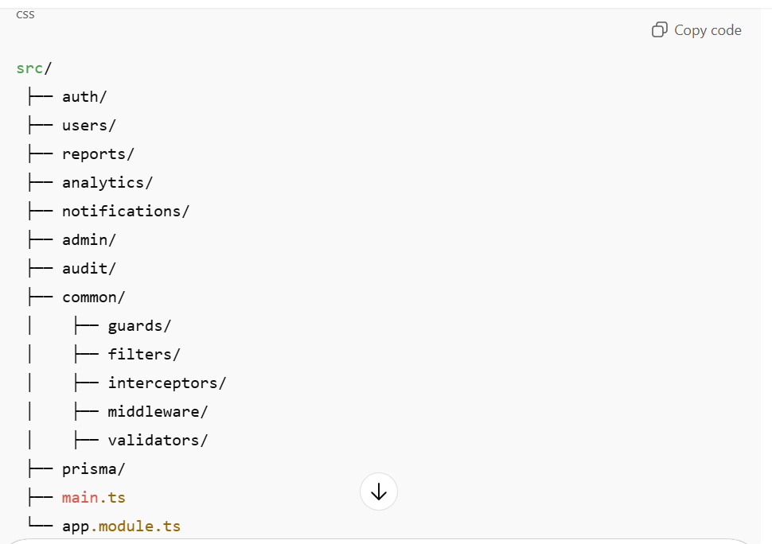
Any deviation requires explicit justification.

8.2 Module Responsibilities
Module | Responsibility
auth | Authentication & token management
users | User profiles & roles
reports | Threat reporting lifecycle
analytics | Aggregation & intelligence
notifications | Alerts & messages
admin | System governance
audit | Immutable logging

SECTION 9: MIDDLEWARE EXECUTION ORDER (CRITICAL)
Middleware must execute in this exact order:
- Helmet (security headers)
- Rate Limiting
- Body Parsing
- CSRF Protection
- Authentication Guard
- Authorization Guard
- Input Validation (DTOs)
- Controller Logic
- Audit Logging
- Error Handling
Changing this order introduces vulnerabilities.

SECTION 10: SCALABILITY & STATE MANAGEMENT
10.1 Stateless Backend Rule
- No session storage in memory
- JWT used for authentication
- Horizontal scaling assumed
- Backend instances interchangeable

10.2 Load Handling Assumptions
- Traffic spikes during incidents
- Rate limiting protects backend
- Database indexes required
- Connection pooling enabled

SECTION 11: ENVIRONMENT CONFIGURATION
11.1 Environment Separation
- .env.local
- .env.staging
- .env.production
No environment variables hardcoded.

11.2 Secrets Handling
- JWT secrets stored securely
- Database credentials never logged
- Production secrets never committed
PHASE 4 — DATABASE ARCHITECTURE & DATA MODELS
4.1 Database Strategy (MANDATORY)
Primary Database:
- PostgreSQL 15
Reason (non-negotiable):
- ACID compliance for threat reports
- Strong relational integrity
- Native JSONB support (for threat metadata)
- Excellent performance at 4,000–7,500 concurrent users
- Mature ecosystem and security tooling
ORM Layer:
- Prisma ORM
Why Prisma:
- Deterministic schema generation
- Type-safe queries
- Migration control
- Perfect for AI-driven code generation
- Prevents SQL injection by design
Caching Layer:
- Redis
- Used for:
  - Rate limiting
  - Session storage
  - Temporary threat intelligence caching

4.2 Core Design Principles (STRICT)
- No redundant data
- All relationships explicitly defined
- Every table must have:
  - id
  - created_at
  - updated_at
- Every foreign key indexed
- Soft deletes only where necessary
- Auditability is mandatory

4.3 Entity Relationship Overview
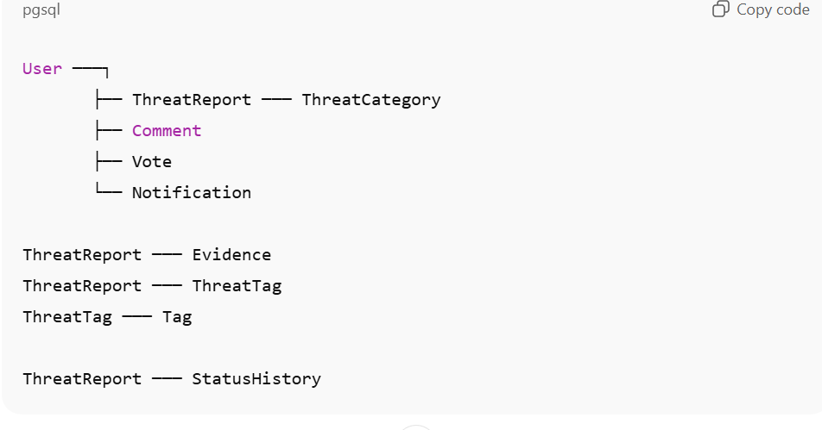

4.4 Database Tables (FULL SCHEMA)

4.4.1 users
Stores all platform users.
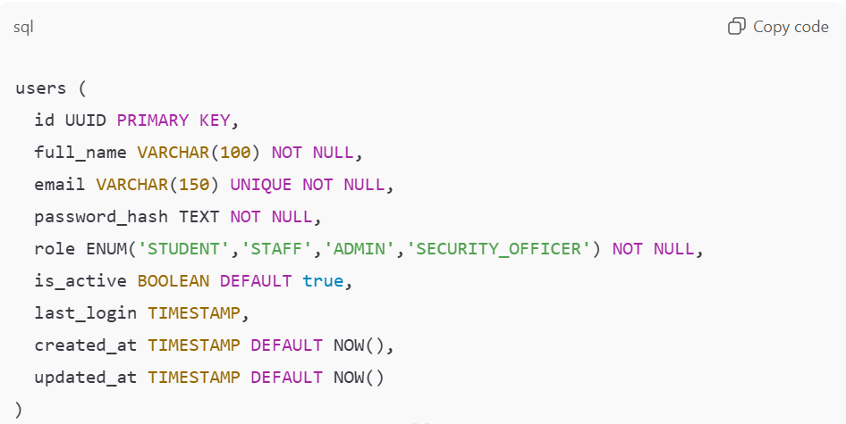
Indexes:
- email
- role

4.4.2 threat_categories
Predefined threat classifications.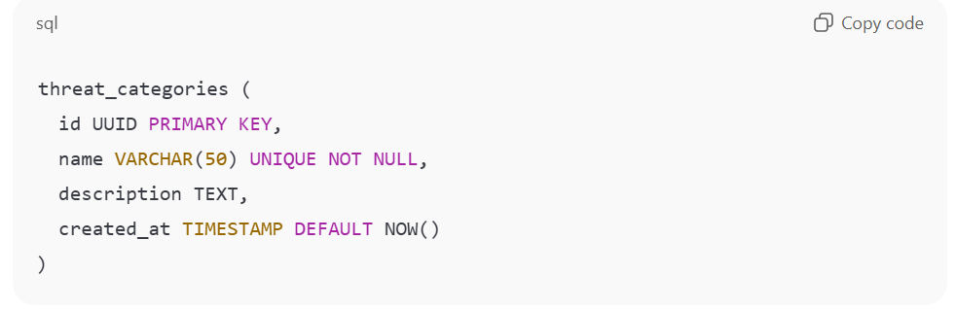
Seeded values:
- Phishing
- Malware
- Data Breach
- Physical Security
- Social Engineering
- Unauthorized Access

4.4.3 threat_reports
Core reporting entity.
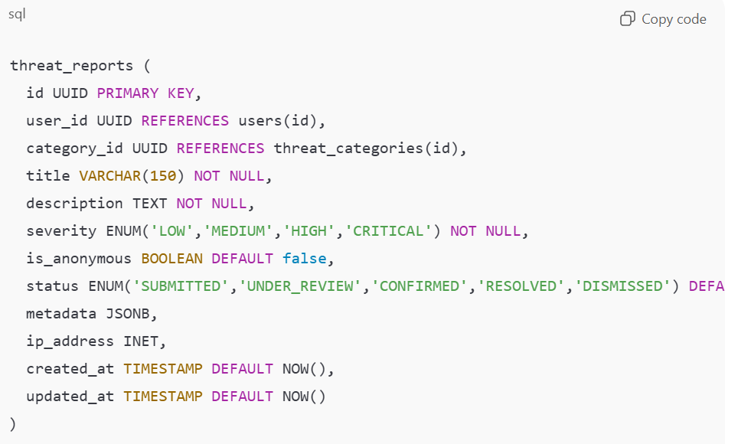

Indexes:
- user_id
- category_id
- status
- severity

4.4.4 evidence
- Stores uploaded proof (screenshots, logs, files).
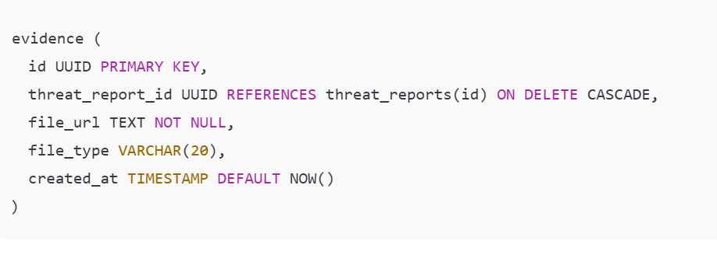
4.4.5 tags
Reusable tagging system.
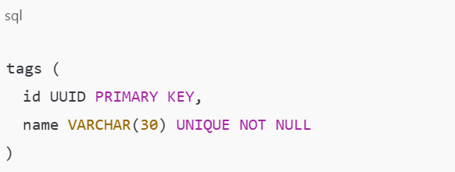
4.4.6 threat_tags (JOIN TABLE)
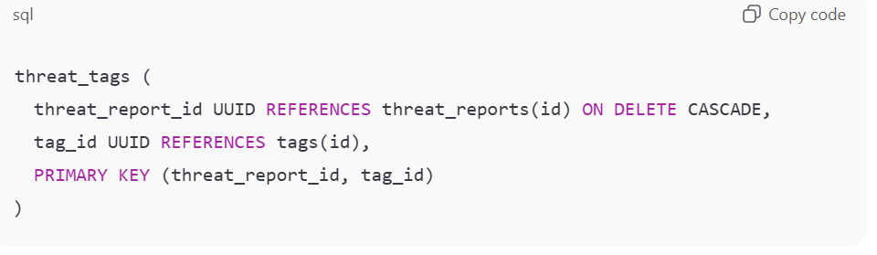
4.4.7 comments
Used for collaboration & investigation.
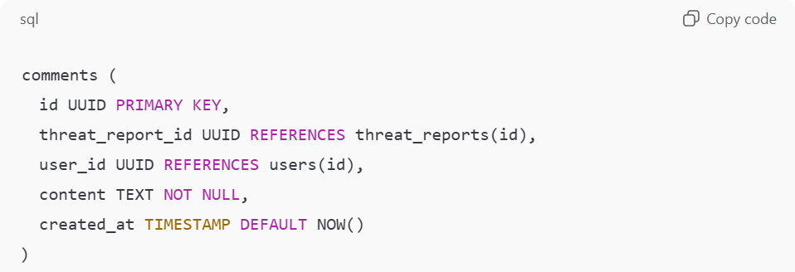
4.4.8 votes
For threat credibility scoring.
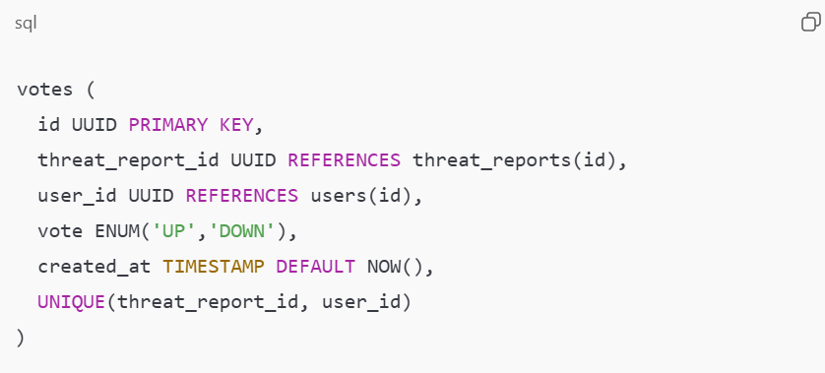

4.4.9 status_history
Audit trail for threat lifecycle.
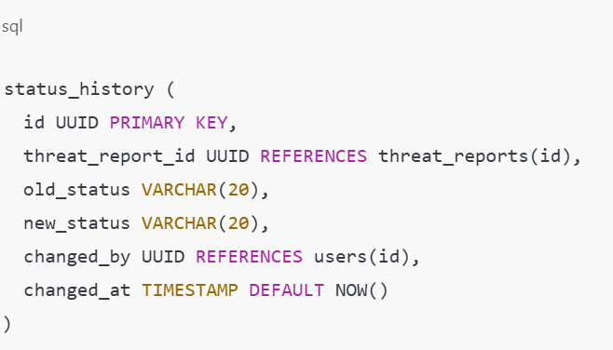
4.4.10 notifications
System-generated alerts.
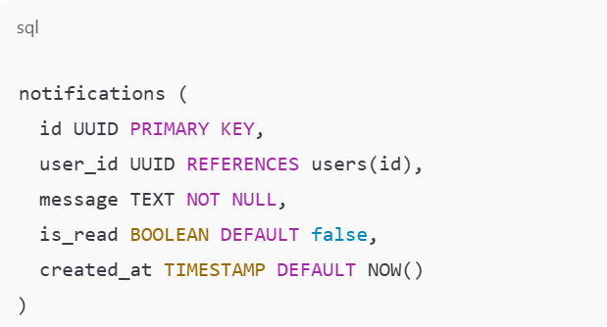
4.5 Input Validation Rules (DATABASE LEVEL)
Mandatory constraints enforced by AI agent:
- Email regex validation
- Enum enforcement (no free-text status)
- Max string lengths enforced
- JSON schema validation for metadata
- File type validation before insert

4.6 Security Constraints (DATABASE)
- No plaintext passwords
- All UUIDs generated server-side
- Role-based query filtering
- Row-level access checks in service layer
- Prepared statements ONLY (via Prisma)

4.7 Scalability Considerations
- Horizontal scaling ready
- Read replicas supported
- Redis offloads hot reads
- Pagination enforced on all list queries
- Indexes optimized for dashboard analytics

4.8 What is OUT OF SCOPE (Database)
❌ Blockchain storage
❌ Unstructured NoSQL databases
❌ Third-party analytics storage
❌ Facial recognition data
❌ Biometric identifiers

4.9 AI AGENT IMPLEMENTATION INSTRUCTIONS
The AI agent MUST:
- Generate Prisma schema exactly matching above
- Auto-generate migrations
- Seed threat categories
- Enforce referential integrity
- Reject schema drift
- Fail build if constraints are violated
PHASE 5 — API CONTRACTS, ENDPOINT SECURITY & RATE LIMITING
5.1 API ARCHITECTURE OVERVIEW
API Style:
- RESTful API (JSON over HTTPS only)
Base URL:
/api/v1
Protocol Rules (MANDATORY):
- HTTPS ONLY
- JSON request & response bodies
- UTF-8 encoding
- No GraphQL
- No SOAP

5.2 AUTHENTICATION & AUTHORIZATION
5.2.1 Authentication Method
JWT-based authentication
- Access Token (short-lived): 15 minutes
- Refresh Token (httpOnly cookie): 7 days
- Token signing: RS256
- Token storage:
  - Access token → memory (frontend)
  - Refresh token → httpOnly secure cookie

5.2.2 Role-Based Access Control (RBAC)
Role | Permissions
STUDENT | Submit & view own reports
STAFF | View non-anonymous reports
SECURITY_OFFICER | Investigate, update status
ADMIN | Full system access
RBAC must be enforced at controller + service layer.

5.3 GLOBAL SECURITY ENFORCEMENT (NON-NEGOTIABLE)
Every endpoint MUST enforce:
- Rate limiting
- JWT validation
- Role check
- Input validation
- Request size limit
- Audit logging
Failure to apply any = build failure

5.4 RATE LIMITING (STRICT)
Tool:
- Redis-backed rate limiter
Limits:
Endpoint Type | Limit
Auth endpoints | 5 req/min
Report submission | 3 req/min
General API | 60 req/min
Admin endpoints | 30 req/min
Rate limiting keys:
- IP address
- User ID (if authenticated)

5.5 INPUT VALIDATION RULES
Validation must be applied using Zod (server-side).
Rules:
- No raw request body access
- Reject malformed JSON
- Reject extra fields
- Enforce max lengths
- Escape HTML
- Reject script tags

5.6 API ENDPOINTS (FULL CONTRACT)

5.6.1 AUTHENTICATION
POST /auth/register
Request:
{
"full_name": "string (3–100)",
"email": "valid email",
"password": "min 8 chars"
}
Response:
{ "message": "Registration successful" }

POST /auth/login
Request:
{
"email": "string",
"password": "string"
}
Response:
{
"accessToken": "JWT"
}

POST /auth/logout
- Invalidates refresh token
- Clears cookie

5.6.2 THREAT REPORTING

POST /threats
Auth: STUDENT / STAFF
Rate limit: 3/min
Request:
{
"title": "max 150 chars",
"description": "required",
"category_id": "UUID",
"severity": "LOW | MEDIUM | HIGH | CRITICAL",
"is_anonymous": true,
"tags": ["phishing", "email"]
}
Security Rules:
- IP logged
- Profanity filter
- XSS sanitization

GET /threats
Auth: All authenticated
Filters: status, severity, category
Pagination mandatory

GET /threats/:id
- Anonymous reports hide reporter identity
- Role-based field masking applied

5.6.3 EVIDENCE UPLOAD

POST /threats/:id/evidence
Max file size: 5MB
Allowed types: PNG, JPG, PDF, TXT
- Virus scan before storage
- Store in cloud object storage
- Save only URL in DB

5.6.4 THREAT MANAGEMENT

PATCH /threats/:id/status
Auth: SECURITY_OFFICER / ADMIN
{
"new_status": "UNDER_REVIEW | CONFIRMED | RESOLVED | DISMISSED"
}
- Status history auto-recorded
- Notification sent

5.6.5 COMMENTS

POST /threats/:id/comments
{
"content": "text"
}
- Length ≤ 1000 chars
- Markdown allowed (sanitized)

5.6.6 VOTING

POST /threats/:id/vote
{
"vote": "UP | DOWN"
}
- One vote per user per threat

5.6.7 NOTIFICATIONS

GET /notifications
- Paginated
- Mark-as-read supported

5.7 AUDIT LOGGING (MANDATORY)
Logged events:
- Login attempts
- Threat creation
- Status changes
- Role changes
- Rate limit violations
Logs stored securely (append-only).

5.8 OWASP THREAT MODELLING ENFORCEMENT
Threats explicitly mitigated:
OWASP Risk | Mitigation
Injection | Prisma + Zod
Broken Auth | JWT + RBAC
XSS | Sanitization
CSRF | SameSite cookies
Rate abuse | Redis limiter
Data exposure | Field masking

5.9 ERROR HANDLING STANDARD
All errors follow:
{
"error": "Human readable message",
"code": "ERROR_CODE"
}
No stack traces in production.

5.10 AI AGENT EXECUTION RULES
The AI agent MUST:
- Generate controllers matching this contract
- Fail build on missing validation
- Enforce rate limits globally
- Implement RBAC strictly
- Log all critical actions
- Reject undocumented endpoints
PHASE 6 — SYSTEM ARCHITECTURE & INFRASTRUCTURE DESIGN
This phase answers three core questions with zero ambiguity:
- What components exist
- How they communicate
- How they scale securely for 4,000–7,500 users

6.1 HIGH-LEVEL ARCHITECTURAL STYLE
Architecture Pattern:
➡️ Secure Layered Architecture with Stateless Backend
Core Principles:
- Separation of concerns
- Stateless services
- Defense-in-depth security
- Horizontal scalability
- Fail-safe defaults

6.2 SYSTEM COMPONENTS (AUTHORITATIVE LIST)
6.2.1 Client Layer
Components:
- Web Browser (Chrome, Firefox, Edge)
- React + TypeScript SPA
Responsibilities:
- UI rendering
- Input collection
- JWT access token handling (memory only)
- Secure API consumption
- Zero business logic

6.2.2 Edge & Gateway Layer
Components:
- Nginx Reverse Proxy
Responsibilities:
- TLS termination (HTTPS only)
- Request forwarding
- IP-based rate limiting (pre-backend)
- Request size limiting
- Static asset delivery
- Header sanitization

6.2.3 Application Layer (Backend)
Components:
- NestJS API (Dockerized)
- Redis (rate limiting & caching)
Responsibilities:
- Authentication & RBAC
- Threat reporting logic
- Validation & sanitization
- OWASP threat mitigation
- Audit logging
- Notification orchestration

6.2.4 Data Layer
Components:
- PostgreSQL 15
- Prisma ORM
Responsibilities:
- Persistent data storage
- Referential integrity
- ACID compliance
- Index-based performance
- Immutable audit logs

6.2.5 Object Storage Layer
Components:
- Cloud Object Storage (S3-compatible)
Responsibilities:
- Evidence file storage
- Virus-scanned uploads
- Access-controlled URLs
- No direct public writes

6.3 SYSTEM ARCHITECTURE DIAGRAM (LOGICAL)
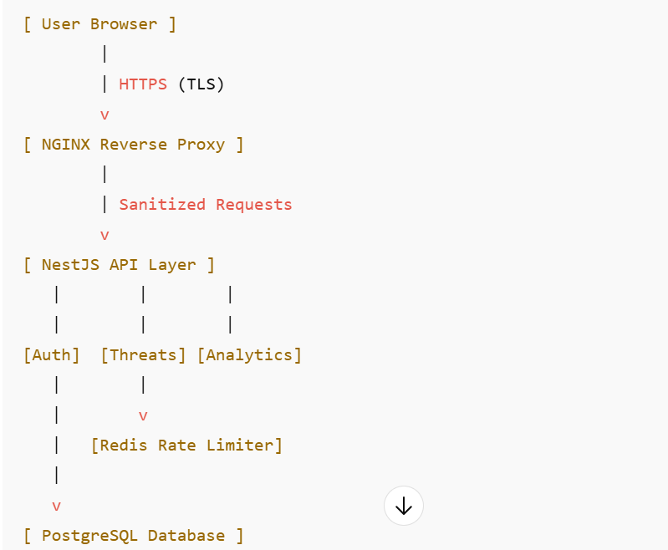
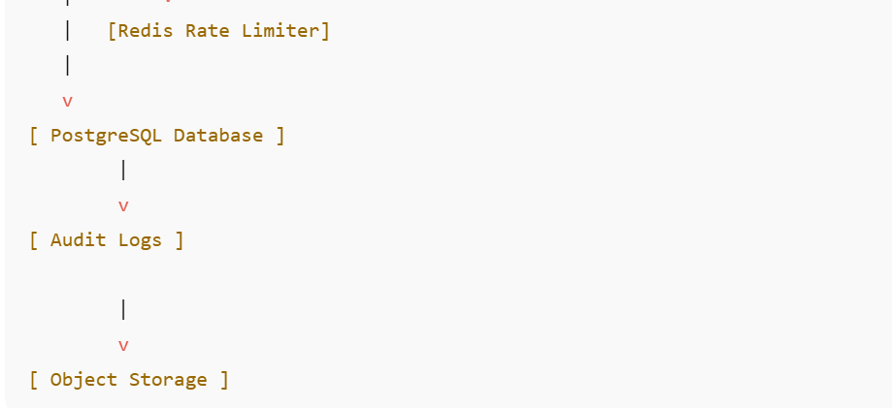

6.4 REQUEST LIFECYCLE (END-TO-END)

Example: Submitting a Threat Report
- User fills report form (Frontend)
- Client-side validation (length, required fields)
- HTTPS request sent
- Nginx:
  - Validates headers
  - Applies IP rate limiting
- NestJS:
  - JWT authentication
  - RBAC authorization
  - DTO validation
  - XSS sanitization
- Redis:
  - User-level rate check
- Database:
  - Transactional insert
- Audit Log written
- Notification triggered
- Response returned

6.5 SCALABILITY ARCHITECTURE
6.5.1 Horizontal Scaling Model
- Backend runs multiple stateless containers
- Load balancing via Nginx
- No shared memory
- Redis & DB are shared services
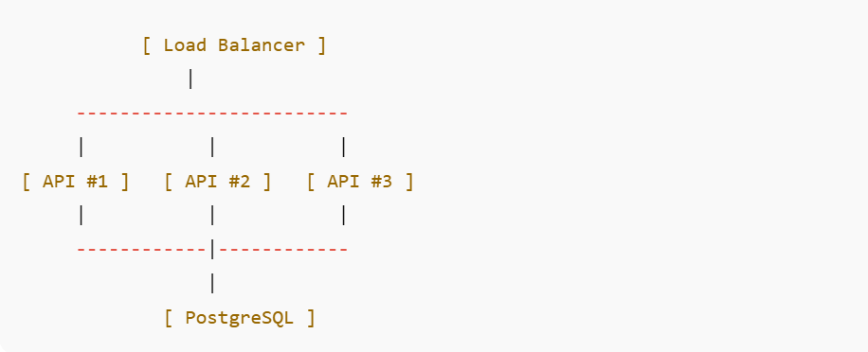
6.5.2 Expected Load Handling
Metric | Target
Concurrent users | 7,500
Peak reports/hour | 500
Avg response time | < 300ms
Max request size | 2MB
6.6 SECURITY BOUNDARIES & TRUST ZONES
Trust Zones
- Public Zone
  - Browser
  - Internet
- DMZ
  - Nginx
  - TLS termination
- Private Zone
  - Backend API
  - Redis
  - Database
Rule:
No public access beyond Nginx.

6.7 FAILURE & RESILIENCE STRATEGY
Backend Failure
- Requests rerouted to healthy instance
- No session loss (stateless)
Database Failure
- Read-only fallback
- Graceful error responses
Rate Limit Trigger
- HTTP 429 returned
- Logged as security event

6.8 LOGGING & OBSERVABILITY ARCHITECTURE
Logs Generated At:
- Gateway (Nginx)
- Backend (NestJS)
- Database (slow queries)
Log Categories:
- Security logs
- Audit logs
- Error logs
- Access logs
Logs are:
- Append-only
- Time-stamped
- Tamper-resistant

PHASE 7 — FRONTEND UI/UX DESIGN SYSTEM & INTERFACE SPECIFICATION
This phase defines:
- Visual identity
- Color system (as previously mandated)
- Typography
- Layout rules
- Every screen & component
- User interaction flows
- Accessibility & consistency constraints
No artistic interpretation is allowed beyond what is written here.

7.1 DESIGN PHILOSOPHY (NON-NEGOTIABLE)
Design Goals:
- Calm, authoritative, secure
- Serious but not intimidating
- Institutional credibility
- Minimal cognitive load
- Zero visual noise
Design Keywords:
Trust • Clarity • Discipline • Subtle Power

7.2 COLOR SYSTEM (LOCKED)
7.2.1 Primary Colors
Purpose | Color | Hex
Primary Brand | Dark Turquoise | #0F766E
Secondary Brand | Turquoise | #14B8A6
Accent | Light Turquoise | #5EEAD4
Background | White | #FFFFFF

7.2.2 Neutral Colors
Use | Hex
Text (Primary) | #0F172A
Text (Secondary) | #475569
Borders | #E2E8F0
Disabled | #CBD5E1
Error | #DC2626
Warning | #D97706
Success | #16A34A

7.2.3 Color Usage Rules
- White backgrounds dominate (≈70%)
- Dark turquoise for headers, nav, buttons
- No gradients
- No neon
- No pure black
- Error colors ONLY for errors

7.3 TYPOGRAPHY SYSTEM
Font Stack (MANDATORY)
- Primary: Inter
- Fallback: system-ui, sans-serif
Font Sizes
Element | Size
Page Titles | 24–28px
Section Headers | 18–20px
Body Text | 14–16px
Labels | 12–14px
Typography Rules
- Sentence case (not ALL CAPS)
- Line height: 1.5
- Max paragraph width: 70ch
- No decorative fonts

7.4 LAYOUT SYSTEM
7.4.1 Grid
- Max width: 1200px
- Centered layout
- 8px spacing scale
- Mobile-first responsive design

7.4.2 Navigation Structure
Top Navigation Bar:
- App name (left)
- Main sections (center)
- User menu (right)
Sidebar (Authenticated users only):
- Dashboard
- Submit Report
- Threat Feed
- Notifications
- Profile
- Admin (role-based)

7.5 GLOBAL UI COMPONENTS
These components must be reused everywhere.

7.5.1 Buttons
Type | Style
Primary | Dark turquoise bg, white text
Secondary | White bg, turquoise border
Danger | Red bg
Disabled | Greyed out
- Rounded corners (6px)
- No shadows
- Hover = slight darken
- Focus ring mandatory

7.5.2 Form Inputs
- White background
- Grey border
- Error state shows red border + message
- Required fields clearly marked
- Password fields show toggle icon

7.5.3 Modals
- Centered
- Dark overlay (30% opacity)
- Close via X or ESC
- No full-screen modals

7.5.4 Tables
- Zebra striping (very subtle)
- Sticky headers
- Sortable columns
- Pagination mandatory

7.6 SCREEN-BY-SCREEN INTERFACE SPECIFICATION

7.6.1 Landing Page (Unauthenticated)
Purpose: Explain system + trust-building
Sections:
- Header (App name + short tagline)
- What the platform does
- Why it matters
- Call-to-action buttons:
  - Login
  - Register
No analytics. No dashboards.

7.6.2 Authentication Screens
Login
- Email
- Password
- Error messages non-specific
- Rate-limit warning displayed
Register
- Name
- Email
- Password
- Password strength indicator

7.6.3 User Dashboard
Purpose: Quick situational awareness
Components:
- Total reports submitted
- Reports under review
- Recent activity list
- Notification preview

7.6.4 Submit Threat Report Page
Critical Screen
Fields:
- Title
- Description (textarea)
- Category (dropdown)
- Severity (radio buttons)
- Tags (multi-select)
- Anonymous toggle
- Evidence upload
Rules:
- Inline validation
- Character counters
- Confirmation modal before submit

7.6.5 Threat Feed Page
Purpose: View all threats
Features:
- Filters (severity, status, category)
- Search
- Pagination
- Severity badges (color-coded)
- Click to open detail view

7.6.6 Threat Detail Page
Displays:
- Full report
- Status timeline
- Evidence attachments
- Comments
- Voting controls
Role-based visibility enforced.

7.6.7 Notifications Page
- Chronological list
- Read/unread states
- Clear-all disabled (intentional friction)

7.6.8 Admin Dashboard
Visible only to ADMIN.
Components:
- User management
- Role assignment
- System metrics
- Audit log viewer (read-only)
7.7 USER FLOW (TEXTUAL DIAGRAM)
Visitor
↓
Landing Page
↓
Register / Login
↓
Dashboard
↓
Submit Report
↓
Confirmation
↓
Threat Feed
↓
Threat Detail
↓
Comments / Updates
Admin flow branches at Dashboard → Admin Panel.
7.8 ACCESSIBILITY (WCAG 2.1 AA)
Mandatory:
- Keyboard navigation
- ARIA labels
- Color contrast ≥ 4.5:1
- Focus indicators
- Screen-reader friendly forms

7.9 UI FAILURE STATES
Every failure must have:
- Clear message
- Neutral tone
- Recovery instruction
No blame language.

7.10 FRONTEND BUILD RULES FOR AI AGENT
The AI agent MUST:
- Use React + TypeScript
- Enforce design tokens
- Reuse components
- Reject inline styling
- Match color codes exactly
- Follow screen specs verbatim
PHASE 8 — DEPLOYMENT, SCALING, CI/CD & PRODUCTION HARDENING

8.1 DEPLOYMENT STRATEGY (MANDATORY)
8.1.1 Deployment Model
Model:
➡️ Containerized, single-region, horizontally scalable deployment
Environments:
- Development
- Staging
- Production
No skipping environments.

8.1.2 Containerization Rules
All services must be Dockerized.
Containers Required:
- Frontend (React)
- Backend (NestJS)
- PostgreSQL
- Redis
- Nginx
Each service runs in its own container.

8.1.3 Docker Rules
- Multi-stage builds required
- No secrets baked into images
- Minimal base images only
- Containers must run as non-root users

8.2 DOCKER COMPOSITION (AUTHORITATIVE)
Services:
Service | Purpose
nginx | Reverse proxy & TLS
api | NestJS backend
frontend | React SPA
postgres | Primary database
redis | Rate limiting & caching

Networking Rules:
- Internal Docker network only
- Database not exposed publicly
- Redis not exposed publicly
- Only Nginx exposed (ports 80/443)

8.3 CI/CD PIPELINE (MANDATORY)
8.3.1 Pipeline Stages
- Code Checkout
- Dependency Installation
- Static Analysis
- Unit Tests
- Security Scan
- Build Docker Images
- Push Images
- Deploy to Staging
- Manual Approval
- Deploy to Production

8.3.2 Mandatory CI Checks
Check | Tool
Linting | ESLint
Type Safety | TypeScript
Unit Tests | Jest
Dependency Scan | npm audit
OWASP Scan | Snyk
Docker Scan | Trivy
Build must fail on:
- Failed tests
- Critical vulnerabilities
- Type errors
- Missing env variables

8.4 DATABASE MIGRATION STRATEGY
- Prisma migrations only
- Migrations applied automatically on deploy
- No manual DB edits
- Rollback scripts required

8.5 SCALING STRATEGY (4,000–7,500 USERS)
8.5.1 Backend Scaling
- Stateless API instances
- Scale horizontally
- Load balanced by Nginx
- Auto-scale based on CPU & latency

8.5.2 Database Scaling
- Vertical scaling initially
- Read replicas (optional future)
- Connection pooling enabled
- Indexed queries only

8.5.3 Redis Scaling
- Centralized Redis instance
- Used only for:
  - Rate limiting
  - Token blacklisting
  - Temporary caches

8.6 PRODUCTION SECURITY HARDENING
8.6.1 Network Security
- Firewall: allow only 80/443
- SSH key-based access only
- Fail2Ban enabled
- Private DB network

8.6.2 Application Security
- Strict CORS rules
- Content Security Policy enforced
- HTTP security headers enabled
- Rate limits enforced twice (Nginx + API)

8.6.3 Secrets Management
- Environment variables only
- Secrets rotated every 90 days
- No secrets in logs
- JWT private keys encrypted at rest

8.7 MONITORING & OBSERVABILITY
Metrics Tracked:
Metric | Target
API latency | < 300ms
Error rate | < 1%
CPU usage | < 70%
Memory usage | < 75%
DB query time | < 100ms

Logs:
- Structured JSON logs
- Centralized collection
- Retention ≥ 90 days
- Immutable audit logs

8.8 BACKUP & DISASTER RECOVERY
Database Backups:
- Daily automated backups
- Encrypted at rest
- Offsite storage
- 30-day retention

Recovery Targets:
- RTO: ≤ 1 hour
- RPO: ≤ 15 minutes

8.9 FAILURE MODES & RESPONSE
Failure | Response
API crash | Auto-restart
Rate abuse | IP blocked
DB overload | Read-only mode
Auth abuse | Account lockout
Data corruption | Restore backup

8.10 PRODUCTION READINESS CHECKLIST
Deployment is blocked unless:
✔ All tests pass
✔ OWASP risks mitigated
✔ Rate limiting verified
✔ Audit logs functioning
✔ Backups confirmed
✔ HTTPS enforced
✔ RBAC validated

8.11 AI AGENT FINAL EXECUTION DIRECTIVES
The AI agent MUST:
- Follow all 8 phases sequentially
- Reject incomplete implementations
- Fail builds on security violations
- Enforce performance thresholds
- Produce deployment-ready artifacts
- Avoid undocumented assumptions

